MENDOCINO SUMMER GUITAR WORKSHOP

Alex de Grassi’s

2017 Mendocino Summer Guitar Workshop

Once again Alex will be joined by Grammy Award winning guitarist and composer Andrew York to lead the 2017 Mendocino Summer Guitar Workshop taking place July 10-16 at the Albion Retreat and Learning Center in Albion, just 7 miles south of the historic town of Mendocino on California’s stunning north coast. This intensive, interactive workshop is for intermediate and advanced guitarists and for singers who play guitar. Alex and Andrew will share their insights into the techniques and inspiration that have become an integral part of their unique styles.

Even if you have contacted us previously requesting a spot in the workshop, please respond to this announcement in order to register!

Scholarships
We are once again offering two tuition-free scholarships to deserving students under 25 years old. Applicants will be required to submit a demo in the form of either an mp3 or a video of their performance. For more information, click here.

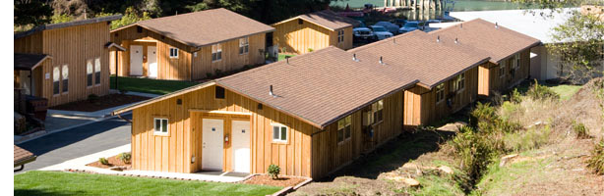
Albion Retreat and Learning Center
Located right on the water at the mouth of the Albion River, the Albion Retreat & Learning Center offers 16 modern cabins, each with three beds and a bathroom. There is a large kitchen, dining hall, and a large meeting room that can accommodate 2 separate sessions simultaneously. The center has its own pier, and canoes and kayaks are provided for those wishing to explore the scenery and wildlife upstream. For more information, please visit
For more information about the facility, please visit www.puc.edu/puc-life/albion/home.
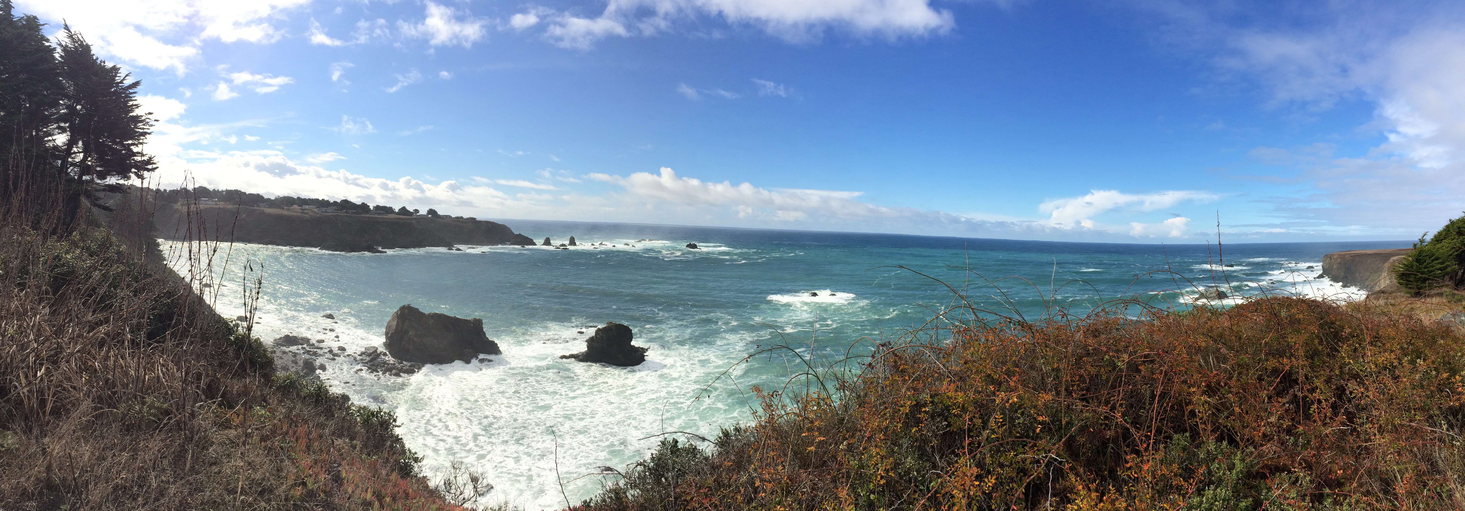
Please do not contact the center directly as we will be handling all accommodations. If you wish to stay an extra night either before or after the workshop, let us know and we will assist you with reservations.

The Workshop
The workshop will focus on performing, arranging, and composing for fingerstyle and classical guitar. Andrew and Alex will share their insights into the techniques and inspiration that have become an integral part of their unique styles.

Dynamics, articulation, phrasing, tone, polyrhythms, right/left hand technique, cross-string technique, extended techniques, and alternate tunings and more will be covered in a very hands-on approach.

This is an interactive workshop designed to improve your playing and ability to arrange music for guitar, whether you are an instrumentalist or a singer who plays guitar as accompaniment.

The four-part format will consist of:
- a master class
- lecture demo
- one-on-one time
- an optional ensemble rehearsal for those who wish to participate in a public performance

Evenings after dinner will be devoted to informal performances, jam sessions, and free time.

Guitarists of all backgrounds are welcome, but should be at least intermediate to advanced fingerstyle players. The workshop is limited to 20 participants. Each participant should be prepared to perform one piece in the master class and another piece informally with the group and/or during the one-on-one session with Andrew or Alex. You should arrive prepared to play:

- A composition or arrangement by a known composer or fingerstyle performer, or an original composition;

- An original composition or an arrangement of a theme to be assigned by Alex at the time of registration.

Optionally, you will receive in advance a part to be played in an ensemble piece composed by either Alex or Andrew.

The ability to read music is not absolutely required, but will be useful. Alex and Andy will hand out music and written exercises in standard notation and/or tablature, so some experience with one or the other will be a plus.

Fees and Registration
The fee is $1,000 per person, and requires a $500 deposit for registration. The fee includes the workshop and gourmet meals (Tuesday dinner through Sunday breakfast) and sleeping accommodations in one of the cabins. Private cabins can be reserved for an additional $50 on a first come, first served basis.

To register for the workshop, please reply to this notice with the following information:
- Name
- Address
- Phone
- Email
- Vegetarian?
- Any Special Dietary Requirements?
- Lodging preference (See Accommodations below. This can also be arranged at a later date.)

Also, please include a very brief description of your playing level, musical training/background, and any performance experience. Though not required, you may send an audio mp3 or link to a video of your performance.

Please note that your registration will not be final until we have received your $350 deposit! Make your check payable to Alex de Grassi and mail to PO Box 772, Redwood Valley, CA 95470 or if you prefer to pay for your deposit via PayPal (you do not need a PayPal account) using your credit card, email the payment to info@degrassi.com.

Refund Policy
Please note that your deposit is refundable up to 30 days before the start of the workshop. Beyond the 30 days we will only refund your deposit if we can fill the place vacated by your cancellation.

Accommodations
The Albion Retreat and Learning Center can accommodate everyone in one of their modern cabins, each of which are equipped with one double bed, two single “bunk” beds, and a bathroom. If you would like to guarantee a private cabin, please request asap; there will be a one-time $50 reservation fee. There are also many wonderful Inns nearby on the coast providing a variety of accommodations for those who prefer extra comfort and privacy. They run the gamut from B&Bs to resorts and motels. Please visit www.visitmendocino.com for lodging options or feel free to us.

Facilities/Activities
Located on the river at the site of an old redwood lumber camp, the Albion Retreat and Learning Center is a former marine biology Field Station operated by Pacific Union College. The facilities are thoroughly modern, and there is one very large conference room that can be divided into two separate meeting rooms for conducting the workshop. There is a modern kitchen and meals will be served in the ample dining room. The center also provides free canoes and kayaks that can be launched from their brand new dock on the Albion River, and wildlife and scenery abound.

The Mendocino Coast is rich with activities include hiking, horseback riding, diving, fishing, riding the historic Skunk Train, wine tasting and more. Guests may want to also avail themselves of the nearby fine dining and shopping, or even choose to stay at one of the many wonderful inns nearby. Please visit www.visitmendocino.com for a complete list.

Food and Drink
Meals will be designed to accommodate vegetarians and non-vegetarians alike. If you have a serious dietary restriction, please contact us well in advance, and we will try to accommodate your needs. Because this facility is operated by a college, alcoholic beverages are not allowed on the premises, however there are two fine restaurants with bars a short walk or drive away—the Ledford House and the Albion River Inn—and there is a general store in the village of Albion with a good selection of wine and beer. If you wish to bring a spouse/partner/family member, there will be an additional $100 dining fee.

Weather
Weather on the Mendocino Coast can be foggy and cool or filled with brilliant sunshine. Bring clothing layers and comfortable walking shoes.

Getting There
The Albion Retreat an Learning Center is located a little over 3 hours by car from San Francisco and Oakland airports, about 4 hours from Sacramento Airport, and about 2 hours from the Santa Rosa airport (service provided by Alaska Airlines/Horizon). We cannot provide transportation, but we will help coordinate ground transportation and carpooling for those who need it. We will provide more specific directions to the Albion Retreat and Learning Center once you have registered for the Workshop.

Contact Us
If you have additional questions, please e-mail us at info@degrassi.com or call us at 707-4318-7932.

